Emergency Plan 6115 Edwards Blvd. Mississauga On

Policy Statement
Cross 3 is committed to having an emergency action plan for each of our workplaces to assist workers and the public in the event of an emergency.
For Emergency Evacuation – Sound Alarm
Stop work. Use nearest exit. Do not return to building to recover personal items. Alert co-workers.
Proceed to designated Muster Station immediately for attendance and await further instructions.
Only return to building when confirmed by your supervisor that Emergency Personnel say it is safe to do so.
MUSTER STATION
Front of building near Flag poles.
USE nearest emergency exit

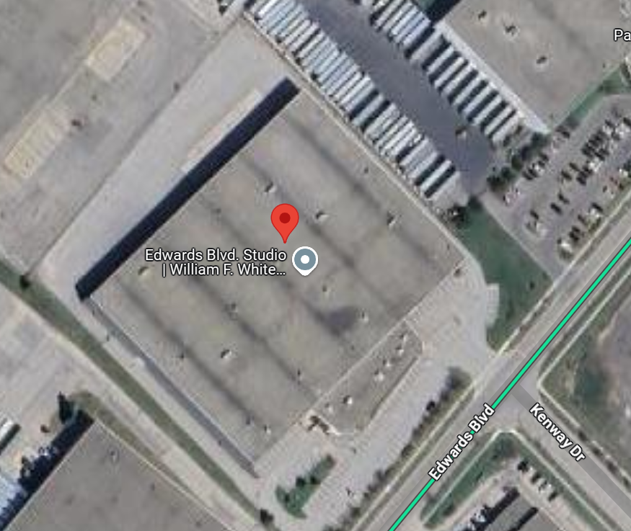
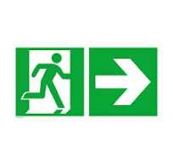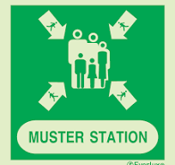

Medical Emergency
At Locations with a Studio and/or Set Medic
2- way radio has proven to be the most efficient form of communication and will be the primary method to alert crews of medical emergencies. Medic’s name and cell number may also be posted in the workplace for non-emergencies or medical inquires but is not required nor can be relied upon in emergencies.
Supervisors, Crews, and Medics will become familiar with standard phraseology for transmitting on 2-way radios. Supervisors and First aid stations will have radios numbered 1-12 which can be retrieved from the medic station. Designated frequency will be channel 9.
Radio Checks
Radio checks are to be completed at beginning of shift or as required. Medic will initiate check with:
“Medic Radio check – Test in 123, 321 Test out”
Handhelds will respond in kind with
“Radio 1 ( 2,3,4 etc.) checked 5x5”(with first digit strength of signal and second number clarity)
Standard Phraseology for Emergencies
“Medic Stage 1, Medic Stage 1” or “Medic Carp Shop, Medic Carp Shop”, etc.
This is a high-level call to action for the Medic’s immediate response to emergency medical situations. This call is made from any available radio and will also raise situational awareness of certified First Aid workers in the area to proceed to the identified location for response or assignment.
Medic is expected to immediately proceed to Designated location.
F1 (first on scene) to Render first aid. Medic assumes F1 upon arrival
-If immediate emergency medical required
-F1 to designate F2, F3, F4.
-F2 to call 911, retrieve reflective vest and proceed to front entrance to guide emergency Services to location of injured.
-F3 to retrieve trauma bag and AED from Medic station if requested. Support F1
-F4 secures the scene, obtains witness names/accounts of accident while event is still fresh in their minds. When time permits, complete eOHS injury report. This will capture the required information for the JHSC to complete an investigation.
When safe to do so, Supervisor will conduct a debriefing with affected crew members and provide contact information for employee assistance as required. JHSC to follow up with crew.
Radios should be charged or returned to the medic station for charging at end of shift

Supervisor / Production Manager to determine if MOL notification required (Critical Injury 420/21).
1. (1) For the purposes of the Act and the Regulations,
“critically injured” means an injury of a serious nature that,
(a) places life in jeopardy,
(b) produces unconsciousness,
(c) results in substantial loss of blood,
(d) involves the fracture of a leg or arm but not a finger or toe,
(e) involves the amputation of a leg, arm, hand or foot but not a finger or toe,
(f) consists of burns to a major portion of the body, or
(g) causes the loss of sight in an eye
If critical injury suspected, contact Production Manager – Heather Young – xxx-xxx-xxxx
Tape off perimeter of accident scene to preserve evidence.
NOTE: IF DEATH OR CRITICAL INJURY – Production Manager will notify MOL. MOL notification is required immediately by TELEPHONE 1-877-202-0008 OR any available means, followed by a written report within 48hrs.

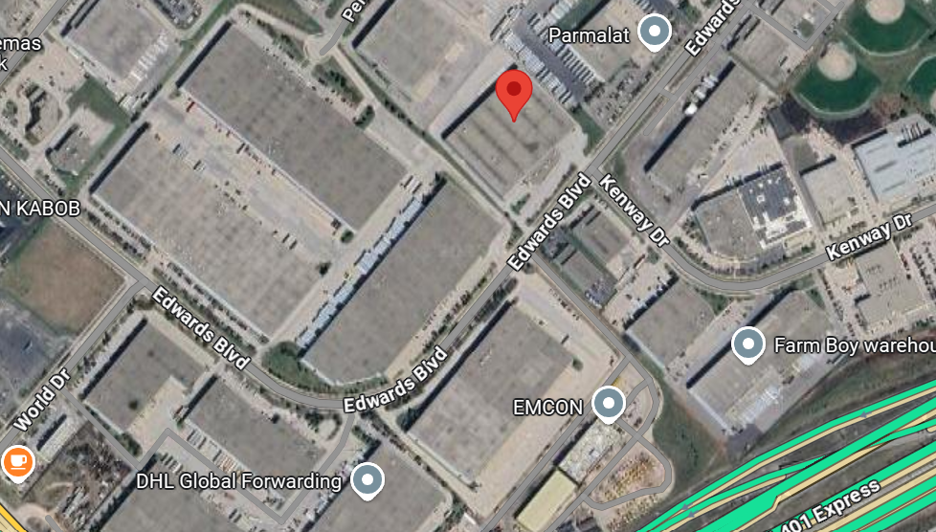

Accident and Injury reporting
All workplace injuries shall be reported to Production via the eOHS safety management system. The report can be submitted by a Medic, Supervisor, injured party, or witness. The app immediately notifies the department Supervisor, Production Manager, and JHSC that an injury has been reported. The report captures the information necessary for the JHSC to investigate to determine if WSIB filing is required, MOL notification is necessary, make recommendations to the Employer to improve safety, or close the report if no action is required.
A paper report and Medic log is also available where report can be recorded then entered into the eOHS app at the earliest convenience. NOTE: An injury report and a WSIB Form 7 are not the same thing
All eOHS injury reports capture the injured persons name, contact info, affected part of body indicating left or right, the mechanism of injury, location where the injury occurred (Studio, Location etc) and out come (returned to work, went home, went to hospital). The person submitting the report can also be included for JHSC follow up. The notes section can be used for additional comments: went to hospital, went home, first aid only etc. This helps triage reports for JHSC investigation.
A FORM 7 SHOULD ONLY BE COMPLETED BY PRODUCTION PAYROLL OR A DESIGANTED COMPANY REPRESENTATIVE (JHSC) AFTER AN INVESTIGATION HAS BEEN COMPLETED TO DETERMINE STATUS OF REPORT OR IF WSIB FILING IS REQUIRED.
THE FORM 7 CONTAINS SENSITIVE PERSONAL INFORMATION THAT IS PROTECTED UNDER PROVINCIAL AND FEDERAL REGULATIONS AND SHOULD NOT BE COMPLETED BY A MEDIC, SUB CONTRACTOR, OR SUPERVISOR UNLESS PRIOR APPROVAL FROM PRODUCTION.
A FORM 7 IS ONLY REQUIRED WHEN:
-The injured party receives outside medical attention from a clinic or hospital
-Is absent from work
-requires modified work at regular pay for than 7 days
The Employer FORM 7 must be filed within three days of learning of an injury or illness at work. A worker has 6 months to complete their FORM 6.
Understanding the WSIB reporting process
FORM 6 – completed by injured party ONLY. Can be done online within 6 months of reported injury
FORM 7- completed by Employer within 3 days from the “Day of Discovery” of WSIB trigger
FORM 8- completed by a regulated health professional
A optional FAF (Functional Abilities Form) may also be completed by a doctor to assist Employers and Workers meet their return to work obligations under the Regulations. This form can be requested by the Employer or voluntarily by the Worker.
A completed FORM 7 must be provided to the Worker

By following these guidelines Regulatory compliance is respected and maintained

