  - Fire Watch guidelines and procedures – 6115 Edwards Blvd

Introduction
A fire watch is an added safety procedure while our fire protection and/or suppression systems may be temporarily degraded or obstructed. The purpose of a fire watch is to monitor a designated area for signs of fire and take immediate action if necessary. This document provides a guide on how to conduct a fire watch, including the responsibilities, required training, and step-by-step procedures for establishing best practices to maintain safety. A Fire Watch will be conducted in Stages 1 through 4 (designated area).
The Role of a Fire Watch
A fire watch is not a passive role. The person assigned to fire watch duties must be trained, alert, and prepared to respond quickly. Their primary responsibilities include:
- Monitoring the designated area at pre-determined intervals for any signs of fire.
- Ensuring that fire protection equipment remains available and accessible.
- Take appropriate action in case of fire.
- Maintaining a log of fire watch inspections.
- Notifying Locations Manager when required

Training
Before assuming fire watch responsibilities, individuals conducting the Fire Watch will complete the following training:
- Recognition of the fire hazards:
Visual, audible, and smell are the best clues and resources to detect fire.
Smoke or flames may be visible, fire/heat sensor alarms may be activated, or the distinguishing smell of burning materials are all indicators a fire may exist.
Portable fire extinguisher training:
- Use and limitations of fire extinguishing equipment. Click the highlighted text to review proper use of portable fire extinguishers
Review emergency evacuation procedures:
-Evacuate the building using the nearest emergency exit
-Assemble at Muster station – Front of building
-Wait for emergency services to arrive
-Identify yourself as fire watch personnel and provide location and intensity of fire
-Do not return to building until told it’s safe to do so by Emergency personnel
-Notify Locations Manager when safe to do so

Procedures: If a fire is detected.
- Call 911 and activate the nearest fire alarm pull station
- If safe to do so, use a fire extinguisher or other suppression equipment to control or extinguish the fire.
- If the fire cannot be controlled evacuate building immediately following the established emergency evacuation procedures above.
- Identify yourself to first responders. Seek first aid as required.
- Report the incident to Location Manager as soon as possible.
Inspection protocols
The eOHS safety management system will be used to log inspections. Inspections will be conducted on an hourly basis once building is considered unoccupied. A QR code will be strategically placed within the inspection area to ensure the integrity of reporting is maintained. Scanning the code will open the Fire Watch inspection log.

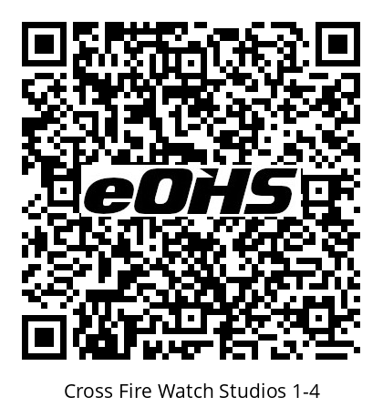
6115 Edwards Blvd, Mississauga
Fire Watch in Effect Stages 1 – 4
This location is protected under provisions of NFPA 140
AHJ – Mississauga Fire Service
Scan code to verify inspection completed in accordance with AHJ Mitigation Approvals
Hourly inspections required
In case of fire call 911

Once opened, Fire Watch personnel can complete the inspection form
There is no mandatory equipment required to conduct the Fire Watch; however, the following is suggested:
- Additional fire extinguishers as required
- Communication device (radio, cell phone) for emergency notifications.
- Flashlight
- Reflective vest

Familiarization of building layout.
The location of the stages at 6115 Edwards Blvd and set layout can be found below. This layout can be printed for reference. It is imperative Fire Watch personnel become familiar with the building layout including the position of fire alarm pull stations and emergency exits. Stage vestibule entrances are marked 1 through 4. QR code positioned near door #4.

North

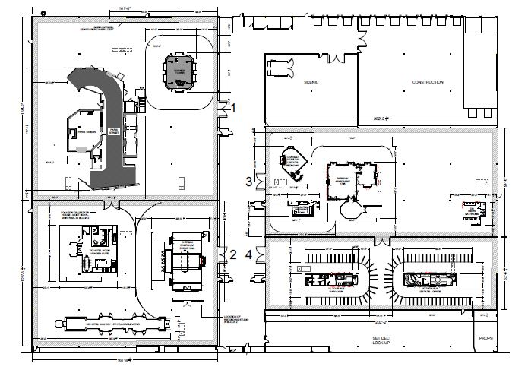

Conducting the Fire Watch
- Confirm that escape routes and emergency exits are clearly marked and unobstructed.
- Complete inspections of Stages 1 -4
- Complete inspection log using eOHS sms QR code

Documentation and Recordkeeping
Maintaining accurate records of fire watch activities is important for regulatory compliance and post-incident analysis. The eOHS sms inspection log will capture the following:
- Date and time of inspection.
- Name of person conducting inspection.
- Confirmation of inspection completed.

Best Practices for Effective Fire Watch
- Assign fire watch duties only to trained and competent individuals.
- Rotate personnel if the fire watch will last for an extended period to prevent fatigue.
- Conduct regular safety briefings and re-evaluate plan as necessary.
- Ensure communication devices are fully functional/charged before starting watch.
- Foster a culture of safety in the workplace, encouraging all employees to recognize and report all safety and fire hazards.

Conclusion
Conducting a fire watch is a vital component of due diligence. Success will depend on the vigilance, training, and preparedness of the designated personnel, as well as the proper implementation of safety guidelines and procedures. By following these guidelines and procedures, acceptable mitigations will be in place to preserve the integrity of the Production and the shooting schedule.

Completion of Training
All Fire Watch personnel with acknowledge they have reviewed these Fire Watch guidelines and procedures.

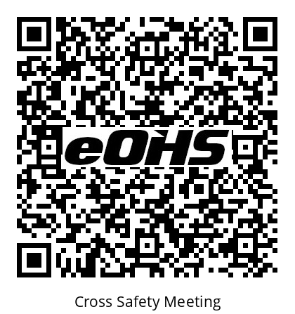
Scan code to acknowledge you have a complete understanding of your responsibilities and the expectations with respect to the guidelines and procedures of conducting a Fire Watch
Contact the JHSC with any questions or concerns
www.Cross3.eohs.tv

