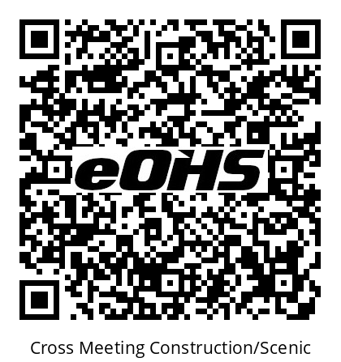
Cross Season 3
Safety Meeting
Scan code to register your attendance
Certified JHSC co-chairs
OHSA 9(12) 9(32)
Max Eves (647)240-3383 worker
Mafalda Gugliuzzi (647)xxx-xxxx production
All hazards and injuries must be reported to Supervisor
eOHS Safety Management System
www.Cross.eohs.tv

Cross Season 3
Safety Meeting
Scan code to register your attendance
Certified JHSC co-chairs
OHSA 9(12) 9(32)
Max Eves (647)240-3383 worker
Mafalda Gugliuzzi (647)xxx-xxxx production
All hazards and injuries must be reported to Supervisor
eOHS Safety Management System
www.Cross.eohs.tv

