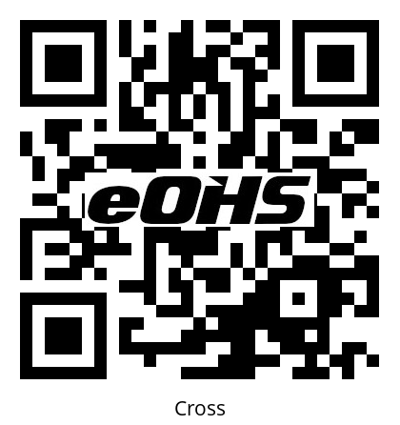
Cross season 3
Anonymous Safety Reporting
Scan code to notify Department Supervisor of hazard or workplace injury
Medic channel 2
Production Safety Hotline
1-866-555-1212
Certified JHSC co-chairs
OHSA 9(12) 9(32)
Max Eves (647) 240-3385 worker
Mafalda Gugliuzzi (647) 298-xxxx production
Shop Steward
Tim Bits (647) xxx-xxxx

Cross season 3
Anonymous Safety Reporting
Scan code to notify Department Supervisor of hazard or workplace injury
Medic channel 2
Production Safety Hotline
1-866-555-1212
Certified JHSC co-chairs
OHSA 9(12) 9(32)
Max Eves (647) 240-3385 worker
Mafalda Gugliuzzi (647) 298-xxxx production
Shop Steward
Tim Bits (647) xxx-xxxx

